Lab - Configuring Multi-area OSPFv3

1. Topology

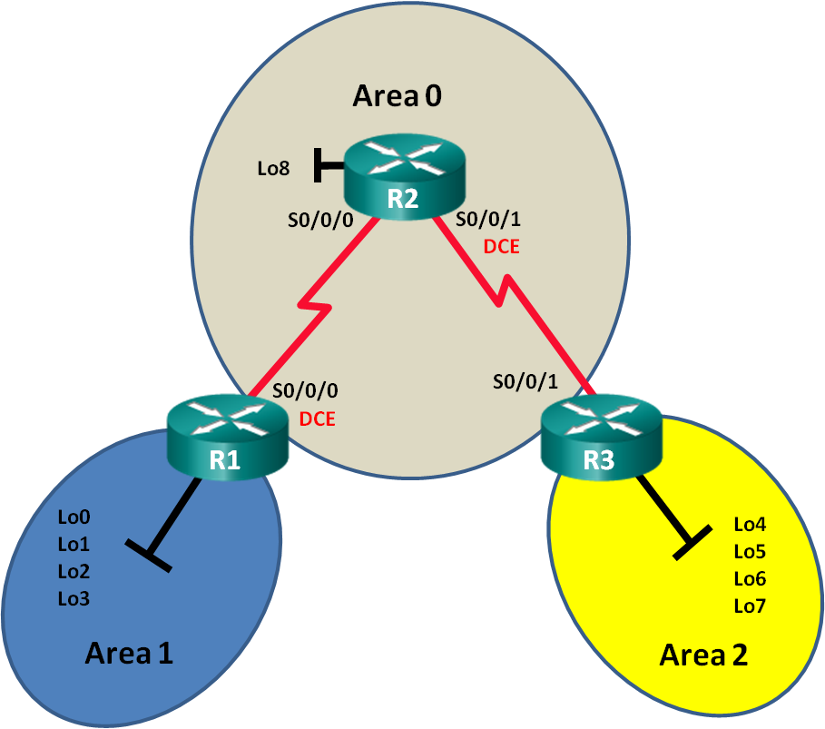

1. Addressing Table

|  |  |  |
| --- | --- | --- |
| Device | Interface | IPv6 Address |
| R1 | S0/0/0 (DCE) | 2001:DB8:ACAD:12::1/64  FE80::1 link-local |
| Lo0 | 2001:DB8:ACAD::1/64 |
| Lo1 | 2001:DB8:ACAD:1::1/64 |
| Lo2 | 2001:DB8:ACAD:2::1/64 |
| Lo3 | 2001:DB8:ACAD:3::1/64 |
| R2 | S0/0/0 | 2001:DB8:ACAD:12::2/64  FE80::2 link-local |
| S0/0/1 (DCE) | 2001:DB8:ACAD:23::2/64  FE80::2 link-local |
| Lo8 | 2001:DB8:ACAD:8::1/64 |
| R3 | S0/0/1 | 2001:DB8:ACAD:23::3/64  FE80::3 link-local |
| Lo4 | 2001:DB8:ACAD:4::1/64 |
| Lo5 | 2001:DB8:ACAD:5::1/64 |
| Lo6 | 2001:DB8:ACAD:6::1/64 |
| Lo7 | 2001:DB8:ACAD:7::1/64 |

1. Objectives

Part 1: Build the Network and Configure Basic Device Settings

Part 2: Configure Multi-area OSPFv3 Routing

1. Background / Scenario

Using multi-area OSPFv3 in large IPv6 network deployments can reduce router processing cycles by creating smaller routing tables and requiring less memory overhead. In multi-area OSPFv3, all areas are connected to the backbone area (area 0) through area border routers (ABRs).

In this lab, you will implement OSPFv3 routing for multiple areas. You will also use a number of **show** commands to display and verify OSPFv3 routing information. This lab uses loopback addresses to simulate networks in multiple OSPFv3 areas.

**Note**: The routers used with CCNA hands-on labs are Cisco 1941 Integrated Services Routers (ISRs) with Cisco IOS Release 15.2(4)M3 (universalk9 image). Other routers and Cisco IOS versions can be used. Depending on the model and Cisco IOS version, the commands available and output produced might vary from what is shown in the labs. Refer to the Router Interface Summary Table at this end of this lab for the correct interface identifiers.

**Note**: Make sure that the routers have been erased and have no startup configurations. If you are unsure, contact your instructor.

1. Required Resources

* 3 Routers (Cisco 1941 with Cisco IOS Release 15.2(4)M3 universal image or comparable)
* 3 PCs (Windows with terminal emulation program, such as Tera Term)
* Console cables to configure the Cisco IOS devices via the console ports
* Serial cables as shown in the topology

1. Build the Network and Configure Basic Device Settings

In Part 1, you will set up the network topology and configure basic settings on the routers.

* 1. Cable the network as shown in the topology.
  2. Initialize and reload the routers as necessary.
  3. Configure basic settings for each router.
     1. Disable DNS lookup.
     2. Configure device name as shown in the topology.
     3. Assign **class** as the privileged EXEC password.
     4. Assign **cisco** as the vty password.
     5. Configure a MOTD banner to warn users that unauthorized access is prohibited.
     6. Configure **logging synchronous** for the console line.
     7. Encrypt plaintext passwords.
     8. Configure the IPv6 unicast and link-local addresses listed in the Addressing Table for all interfaces.
     9. Enable IPv6 unicast routing on each router.
     10. Copy the running configuration to the startup configuration.
  4. Test connectivity.

The routers should be able to ping one another. The routers are unable to ping distant loopbacks until OSPFv3 routing is configured. Verify and troubleshoot if necessary.

1. Configure Multi-area OSPFv3 Routing

In Part 2, you will configure OSPFv3 routing on all routers to separate the network domain into three distinct areas, and then verify that routing tables are updated correctly.

* 1. Assign router IDs.
     1. On R1, issue the **ipv6 router ospf** command to start an OSPFv3 process on the router.

R1(config)# **ipv6 router ospf 1**

**Note**: The OSPF process ID is kept locally and has no meaning to other routers on the network.

* + 1. Assign the OSPFv3 router ID **1.1.1.1** to R1.

R1(config-rtr)# **router-id 1.1.1.1**

* + 1. Start an OSPFv3 process on R2 and R3 and assign a router ID of **2.2.2.2** to R2 and a router ID of **3.3.3.3** to R3.
    2. Issue the **show ipv6 ospf** command to verify the router IDs on all routers.

R2# **show ipv6 ospf**

Routing Process "ospfv3 1" with ID 2.2.2.2

Event-log enabled, Maximum number of events: 1000, Mode: cyclic

Router is not originating router-LSAs with maximum metric

<output omitted>

* 1. Configure multi-area OSPFv3.
     1. Issue the **ipv6 ospf 1 area** *area-id* command for each interface on R1 that is to participate in OSPFv3 routing. The loopback interfaces are assigned to area 1 and the serial interface is assigned to area 0. You will change the network type on the loopback interfaces to ensure that the correct subnet is advertised.

R1(config)# **interface lo0**

R1(config-if)# **ipv6 ospf 1 area 1**

R1(config-if)# **ipv6 ospf network point-to-point**

R1(config-if)# **interface lo1**

R1(config-if)# **ipv6 ospf 1 area 1**

R1(config-if)# **ipv6 ospf network point-to-point**

R1(config-if)# **interface lo2**

R1(config-if)# **ipv6 ospf 1 area 1**

R1(config-if)# **ipv6 ospf network point-to-point**

R1(config-if)# **interface lo3**

R1(config-if)# **ipv6 ospf 1 area 1**

R1(config-if)# **ipv6 ospf network point-to-point**

R1(config-if)# **interface s0/0/0**

R1(config-if)# **ipv6 ospf 1 area 0**

* + 1. Use the **show ipv6 protocols** command to verify multi-area OSPFv3 status.

R1# **show ipv6 protocols**

IPv6 Routing Protocol is "connected"

IPv6 Routing Protocol is "ND"

IPv6 Routing Protocol is "ospf 1"

Router ID 1.1.1.1

Area border router

Number of areas: 2 normal, 0 stub, 0 nssa

Interfaces (Area 0):

Serial0/0/0

Interfaces (Area 1):

Loopback0

Loopback1

Loopback2

Loopback3

Redistribution:

None

* + 1. Assign all interfaces on R2 to participate in OSPFv3 area 0. For the loopback interface, change the network type to point-to point. Write the commands used in the space below.

____________________________________________________________________________________

____________________________________________________________________________________

____________________________________________________________________________________

____________________________________________________________________________________

____________________________________________________________________________________

____________________________________________________________________________________

* + 1. Use the **show ipv6 ospf interface brief** command to view OSPFv3-enabled interfaces.

R2# **show ipv6 ospf interface brief**

Interface PID Area Intf ID Cost State Nbrs F/C

Lo8 1 0 13 1 P2P 0/0

Se0/0/1 1 0 7 64 P2P 1/1

Se0/0/0 1 0 6 64 P2P 1/1

* + 1. Assign the loopback interfaces on R3 to participate in OSPFv3 area 2 and change the network type to point-to-point. Assign the serial interface to participate in OSPFv3 area 0. Write the commands used in the space below.

____________________________________________________________________________________

____________________________________________________________________________________

____________________________________________________________________________________

____________________________________________________________________________________

____________________________________________________________________________________

____________________________________________________________________________________

____________________________________________________________________________________

____________________________________________________________________________________

____________________________________________________________________________________

* + 1. Use the **show ipv6 ospf** command to verify configurations.

R3# **show ipv6 ospf**

Routing Process "ospfv3 1" with ID 3.3.3.3

Event-log enabled, Maximum number of events: 1000, Mode: cyclic

It is an area border router

Router is not originating router-LSAs with maximum metric

Initial SPF schedule delay 5000 msecs

Minimum hold time between two consecutive SPFs 10000 msecs

Maximum wait time between two consecutive SPFs 10000 msecs

Minimum LSA interval 5 secs

Minimum LSA arrival 1000 msecs

LSA group pacing timer 240 secs

Interface flood pacing timer 33 msecs

Retransmission pacing timer 66 msecs

Number of external LSA 0. Checksum Sum 0x000000

Number of areas in this router is 2. 2 normal 0 stub 0 nssa

Graceful restart helper support enabled

Reference bandwidth unit is 100 mbps

RFC1583 compatibility enabled

Area BACKBONE(0)

Number of interfaces in this area is 1

SPF algorithm executed 2 times

Number of LSA 16. Checksum Sum 0x0929F8

Number of DCbitless LSA 0

Number of indication LSA 0

Number of DoNotAge LSA 0

Flood list length 0

Area 2

Number of interfaces in this area is 4

SPF algorithm executed 2 times

Number of LSA 13. Checksum Sum 0x048E3C

Number of DCbitless LSA 0

Number of indication LSA 0

Number of DoNotAge LSA 0

Flood list length 0

* 1. Verify OSPFv3 neighbors and routing information.
     1. Issue the **show ipv6 ospf neighbor** command on all routers to verify that each router is listing the correct routers as neighbors.

R1# **show ipv6 ospf neighbor**

OSPFv3 Router with ID (1.1.1.1) (Process ID 1)

Neighbor ID Pri State Dead Time Interface ID Interface

2.2.2.2 0 FULL/ - 00:00:39 6 Serial0/0/0

* + 1. Issue the **show ipv6 route ospf** command on all routers to verify that each router has learned routes to all networks in the Addressing Table.

R1# **show ipv6 route ospf**

IPv6 Routing Table - default - 16 entries

Codes: C - Connected, L - Local, S - Static, U - Per-user Static route

B - BGP, R - RIP, H - NHRP, I1 - ISIS L1

I2 - ISIS L2, IA - ISIS interarea, IS - ISIS summary, D - EIGRP

EX - EIGRP external, ND - ND Default, NDp - ND Prefix, DCE - Destination

NDr - Redirect, O - OSPF Intra, OI - OSPF Inter, OE1 - OSPF ext 1

OE2 - OSPF ext 2, ON1 - OSPF NSSA ext 1, ON2 - OSPF NSSA ext 2

OI 2001:DB8:ACAD:4::/64 [110/129]

via FE80::2, Serial0/0/0

OI 2001:DB8:ACAD:5::/64 [110/129]

via FE80::2, Serial0/0/0

OI 2001:DB8:ACAD:6::/64 [110/129]

via FE80::2, Serial0/0/0

OI 2001:DB8:ACAD:7::/64 [110/129]

via FE80::2, Serial0/0/0

O 2001:DB8:ACAD:8::/64 [110/65]

via FE80::2, Serial0/0/0

O 2001:DB8:ACAD:23::/64 [110/128]

via FE80::2, Serial0/0/0

What does OI stand for? How was the OI route learned?

____________________________________________________________________________________

* + 1. Issue the **show ipv6 ospf database** command on all routers.

R1# **show ipv6 ospf database**

OSPFv3 Router with ID (1.1.1.1) (Process ID 1)

Router Link States (Area 0)

ADV Router Age Seq# Fragment ID Link count Bits

1.1.1.1 908 0x80000001 0 1 B

2.2.2.2 898 0x80000003 0 2 None

3.3.3.3 899 0x80000001 0 1 B

Inter Area Prefix Link States (Area 0)

ADV Router Age Seq# Prefix

1.1.1.1 907 0x80000001 2001:DB8:ACAD::/62

3.3.3.3 898 0x80000001 2001:DB8:ACAD:4::/62

Link (Type-8) Link States (Area 0)

ADV Router Age Seq# Link ID Interface

1.1.1.1 908 0x80000001 6 Se0/0/0

2.2.2.2 909 0x80000002 6 Se0/0/0

Intra Area Prefix Link States (Area 0)

ADV Router Age Seq# Link ID Ref-lstype Ref-LSID

1.1.1.1 908 0x80000001 0 0x2001 0

2.2.2.2 898 0x80000003 0 0x2001 0

3.3.3.3 899 0x80000001 0 0x2001 0

Router Link States (Area 1)

ADV Router Age Seq# Fragment ID Link count Bits

1.1.1.1 908 0x80000001 0 0 B

Inter Area Prefix Link States (Area 1)

ADV Router Age Seq# Prefix

1.1.1.1 907 0x80000001 2001:DB8:ACAD:12::/64

1.1.1.1 907 0x80000001 2001:DB8:ACAD:8::/64

1.1.1.1 888 0x80000001 2001:DB8:ACAD:23::/64

1.1.1.1 888 0x80000001 2001:DB8:ACAD:4::/62

Link (Type-8) Link States (Area 1)

ADV Router Age Seq# Link ID Interface

1.1.1.1 908 0x80000001 13 Lo0

1.1.1.1 908 0x80000001 14 Lo1

1.1.1.1 908 0x80000001 15 Lo2

1.1.1.1 908 0x80000001 16 Lo3

Intra Area Prefix Link States (Area 1)

ADV Router Age Seq# Link ID Ref-lstype Ref-LSID

1.1.1.1 908 0x80000001 0 0x2001 0

How many link state databases are found on R1? _____

How many link state databases are found on R2? _____

How many link state databases are found on R3? _____

1. Reflection
   1. Why would multi-area OSPFv3 be used?

_______________________________________________________________________________________

_______________________________________________________________________________________

1. Router Interface Summary Table

|  |  |  |  |  |
| --- | --- | --- | --- | --- |
| Router Interface Summary | | | | |
| Router Model | Ethernet Interface #1 | Ethernet Interface #2 | Serial Interface #1 | Serial Interface #2 |
| 1800 | Fast Ethernet 0/0 (F0/0) | Fast Ethernet 0/1 (F0/1) | Serial 0/0/0 (S0/0/0) | Serial 0/0/1 (S0/0/1) |
| 1900 | Gigabit Ethernet 0/0 (G0/0) | Gigabit Ethernet 0/1 (G0/1) | Serial 0/0/0 (S0/0/0) | Serial 0/0/1 (S0/0/1) |
| 2801 | Fast Ethernet 0/0 (F0/0) | Fast Ethernet 0/1 (F0/1) | Serial 0/1/0 (S0/1/0) | Serial 0/1/1 (S0/1/1) |
| 2811 | Fast Ethernet 0/0 (F0/0) | Fast Ethernet 0/1 (F0/1) | Serial 0/0/0 (S0/0/0) | Serial 0/0/1 (S0/0/1) |
| 2900 | Gigabit Ethernet 0/0 (G0/0) | Gigabit Ethernet 0/1 (G0/1) | Serial 0/0/0 (S0/0/0) | Serial 0/0/1 (S0/0/1) |
| **Note**: To find out how the router is configured, look at the interfaces to identify the type of router and how many interfaces the router has. There is no way to effectively list all the combinations of configurations for each router class. This table includes identifiers for the possible combinations of Ethernet and Serial interfaces in the device. The table does not include any other type of interface, even though a specific router may contain one. An example of this might be an ISDN BRI interface. The string in parenthesis is the legal abbreviation that can be used in Cisco IOS commands to represent the interface. | | | | |